Exercise 2: Error Handling

BY: Shubham Sangram Bej

Aim
To implement PL/SQL stored procedures that demonstrate exception handling while performing banking operations. The exercise focuses on maintaining data integrity using transactions, handling runtime errors, and displaying meaningful messages.

Scenario 1: Safe Fund Transfer

Problem Statement
Handle exceptions during fund transfers between accounts. Write a stored procedure SafeTransferFunds that transfers funds between two accounts. Ensure that if any error occurs (e.g., insufficient funds), an appropriate error message is logged and the transaction is rolled back.

Algorithm
- Accept sender account ID, receiver account ID, and transfer amount.
- Retrieve the balance of the sender's account.
- Check whether the balance is sufficient.
- If sufficient:
  - Deduct the amount from the sender's account.
  - Add the amount to the receiver's account.
  - Commit the transaction.
- If any error occurs:
  - Roll back the transaction.
  - Display the corresponding error message.

Program
CREATE OR REPLACE PROCEDURE SAFETRANSFERFUNDS (
P_FROM_ACCOUNT IN NUMBER,
P_TO_ACCOUNT IN NUMBER,
P_AMOUNT IN NUMBER
) AS
V_BALANCE NUMBER;
BEGIN
-- Get sender balance
SELECT
BALANCE
INTO V_BALANCE
FROM
ACCOUNTS
WHERE
ACCOUNTID = P_FROM_ACCOUNT;

-- Check sufficient balance
IF V_BALANCE < P_AMOUNT THEN
RAISE_APPLICATION_ERROR(-20001, 'Insufficient Balance.');
END IF;

-- Debit sender
UPDATE ACCOUNTS
SET
BALANCE = BALANCE - P_AMOUNT,
LASTMODIFIED = SYSDATE
WHERE
ACCOUNTID = P_FROM_ACCOUNT;

-- Credit receiver
UPDATE ACCOUNTS
SET
BALANCE = BALANCE + P_AMOUNT,
LASTMODIFIED = SYSDATE
WHERE
ACCOUNTID = P_TO_ACCOUNT;

COMMIT;
DBMS_OUTPUT.PUT_LINE('Funds transferred successfully.');
EXCEPTION
WHEN OTHERS THEN
ROLLBACK;
DBMS_OUTPUT.PUT_LINE('Transfer Failed: ' || SQLERRM);
END;
/

BEGIN
SAFETRANSFERFUNDS(1, 2, 500);
END;
/

Output
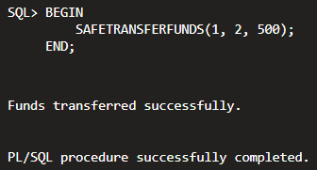
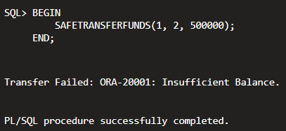

Updated Accounts Table

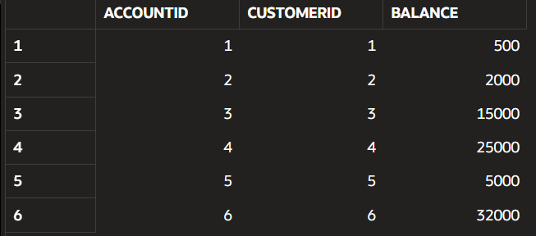

Scenario 2: Employee Salary Update

Problem Statement

Manage errors when updating employee salaries. Write a stored procedure UpdateSalary that increases the salary of an employee by a given percentage. If the employee ID does not exist, handle the exception and log an error message.

Algorithm
- Accept employee ID and percentage increase.
- Update the employee's salary using the given percentage.
- Check whether any row was updated.
- If no matching employee exists:
  - Raise an exception.
- If the update is successful:
  - Commit the transaction.
- If an error occurs:
  - Roll back the transaction.
  - Display the error message.
Program
CREATE OR REPLACE PROCEDURE UPDATESALARY (
P_EMPLOYEE_ID NUMBER,
P_PERCENTAGE NUMBER
) AS
BEGIN
UPDATE EMPLOYEES
SET
SALARY = SALARY + ( SALARY * P_PERCENTAGE / 100 )
WHERE
EMPLOYEEID = P_EMPLOYEE_ID;

IF SQL%ROWCOUNT = 0 THEN
RAISE_APPLICATION_ERROR(-20002, 'Employee ID not found.');
END IF;
COMMIT;
DBMS_OUTPUT.PUT_LINE('Salary updated successfully.');
EXCEPTION
WHEN OTHERS THEN
ROLLBACK;
DBMS_OUTPUT.PUT_LINE('Error: ' || SQLERRM);
END;
/

BEGIN
UPDATESALARY(1, 10);
END;
/

Output
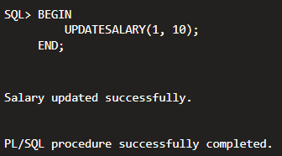

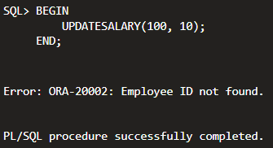

Updated Employees Table

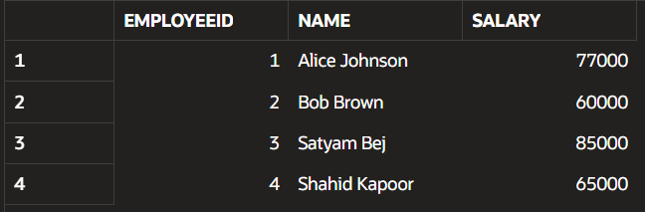

Scenario 3: Add New Customer

Problem Statement

Ensure data integrity when adding a new customer. Write a stored procedure, AddNewCustomer, that inserts a new customer into the Customers table. If a customer with the same ID already exists, handle the exception by logging an error and preventing the insertion.

Algorithm
- Accept customer details as input.
- Insert the new customer into the Customers table.
- Commit the transaction if insertion is successful.
- If a duplicate Customer ID exists:
  - Handle the exception.
  - Display an error message.
- Roll back the transaction for any unexpected error.

Program
CREATE OR REPLACE PROCEDURE ADDNEWCUSTOMER (
P_CUSTOMERID NUMBER,
P_NAME VARCHAR2,
P_DOB DATE,
P_BALANCE NUMBER
) AS
BEGIN
INSERT INTO CUSTOMERS (
CUSTOMERID,
NAME,
DOB,
BALANCE,
LASTMODIFIED,
ISVIP
) VALUES ( P_CUSTOMERID,
P_NAME,
P_DOB,
P_BALANCE,
SYSDATE,
'N' );

COMMIT;
DBMS_OUTPUT.PUT_LINE('Customer added successfully.');
EXCEPTION
WHEN DUP_VAL_ON_INDEX THEN
DBMS_OUTPUT.PUT_LINE('Customer ID already exists.');
WHEN OTHERS THEN
ROLLBACK;
DBMS_OUTPUT.PUT_LINE('Error: ' || SQLERRM);
END;
/

BEGIN
ADDNEWCUSTOMER(7, 'Virat Kohli', TO_DATE('2001-04-18', 'YYYY-MM-DD'), 8000);
END;
/

Output

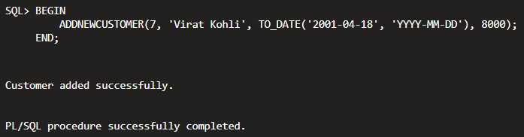
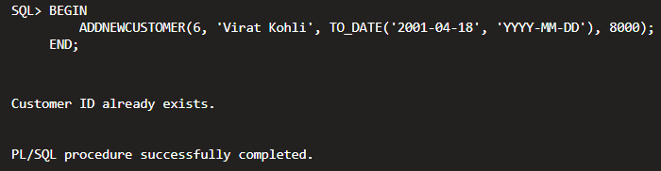

Updated Customers Table

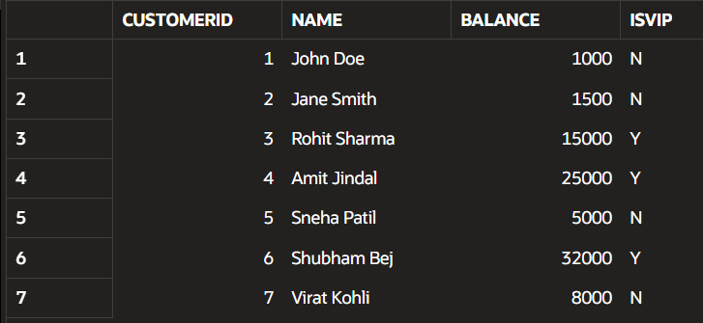

Conclusion
This exercise demonstrated the use of exception handling in PL/SQL stored procedures. The procedures ensured that banking operations such as fund transfers, salary updates, and customer insertion were executed safely while maintaining data consistency. Error handling using EXCEPTION blocks, transaction control through COMMIT and ROLLBACK, and meaningful error messages improved the reliability and integrity of the database operations.

